REFERENCE MANUAL V10.0

Revised: May 1, 2013

&



IntelliQuote Version 10 RM Edition

Welcome!

Thank you for purchasing IntelliQuote Version 10 RM Edition. The RM Edition comes with many new features that you can review at the support web site: http://www.iqcoin.com

This manual is divided up into X Sections:
- Installation
- Chapter 1: XX
- Appendix: Installation and Registration Information

Should you have any problems, concerns or suggestions for improvements, here is our contact information:

Company Coin Nexus, LLC

Contact Carol J. Tailby

Vice President

Correspondence 2835 West Chester Pike
Broomall, PA 19008

Telephone (508) 545-0272

Fax (610) 325-0468

Toll-free (888) 440-VEGA (8342)

Email iqsupport@iqcoin.com or
iqsupport@coinnexus.com

Updates http://www.iqcoin.com

Company Web Sites http://www.coinnexus.com
http://www.dvrarecoins.com
http://www.vegadev.com

1: INTRODUCTION
INTRODUCING INTELLIQUOTE VERSION 10 RM EDITION

IntelliQuote Version 10 RM Edition with PLUS (Proactive Live Update Scheduling) techonology is the most advanced rare coin pricing integration program in the world. It allows you to integrate pricing and population data from:

- Auction Prices Realized (CUAPR)
  - Records go back to 1998
- ATC’s Certified Coin Exchange called CAE
  - Relevant Bid/Ask Pricing information
  - Requires paid subscription
- Coin Dealer Newsletter
  - Greysheet Weekly Edition
  - Greysheet Monthly Supplement
  - Greysheet Quarterly I, II & III
  - Blue Sheet Weekly Edition
  - Requires paid subscription
- Collectors Universe
  - Pricing information
  - Free with purchase of IntelliQuote license
- Coin World Trends
  - Pricing information
  - Requires paid subscription
- Numismedia
  - Market Values
  - Fair Market Values
- NGC
  - Population
  - Free with purchase of IntelliQuote license
- PCGS
  - Population
  - Free with purchase of IntelliQuote license

IntelliQuote Version 10 RM Edition is powered by the Master Uniform System for Identifying Coins (MUSIC) which is a relational database defining coin attributes. Both grading services (PCGS and NGC) are mapped into MUSIC permitting the system to instantly recognize over 30,000 coins and cross-reference them effortlessly. Coins can be accessed by their PCGS number, by bar scans, by selecting them from a list, or by using our revolutionary MUSIC Tree.

The original IntelliQuote system, first created in 1995, was based upon ATC’s Certified Coin Exchange client. Coins were strictly defined in terms of their PCGS number and coins were grouped according to ATC’s criteria. At its peak, this system recognized about 8000 coins. There was no way to access population or pricing information if the coin was not in the ATC system.

IntelliQuote Version 10 RM Edition contains all the functionality of the original IntelliQuote system right down to the ATC groups and methods of access. The RM Edition also offers the MUSIC Coda and MUSIC Tree for instantly finding a coin of interest. It also offers a side-by-side comparison of the same coin in different lusters like MS/PL/DMPL or color designations like BN/RB/RD. It also offers a detailed breakdown of population by grading service variations or pedigree.

IntelliQuote Version 10 RM Edition actually enhances both PCGS and NGC population figures. We've synthesized the population numbers for any given coin, so the numbers you view for total population reflect all of the coins for that date – including the attributions and pedigrees. If you want to view how we arrived at the total population, simply click on the magnifying glass to see the detail. We've created the best of all worlds - giving dealers a much more accurate picture of the total population.

Further, IntelliQuote Version 10 RM Edition allows access to the power of MUSIC using an External Programming Interface. The technology behind MUSIC can be used to bar scan both PCGS and NGC coins into your external program. This interface is accessible using a COM object that is a web-compatible DLL. A separate document is available with details.

IntelliQuote Version 10 RM Edition is multi-instance, meaning you can have more than one copy open at a time.

Finally, IntelliQuote Version 10 RM Edition has a command line interface permitting you to schedule downloads through Windows Scheduled Task Manager rather than having to remember to set up “sleep” mode like the old system.

The following is a list of the 29 cumulative improvements over the previous versions of IntelliQuote. Note that some of the features were implemented in some lesser fashion previously. It is important to note that all prior versions including IntelliQuote Version 9 have been retired. There will no longer be any new features or bug fixes applied. All updates, maintenance and additional features will be applied or available only within IntelliQuote Version 10 RM Edition.

- Update schedule centrally managed. If the schedule changes (e.g. CWT switches from Thursday to Friday) automatically corrected
- All sources AUTOUPDATE – central manager detects changes/updates to files within 1 hour of posting including MUSIC and APRs.
- Automated and centrally scheduled tasks such as Population Purge and Backup.
- Quick update right from Coda or Tree screen (lunch/bathroom break?). Also available from the menu.
- Full Daily Update available from menu. Identical to launch from Scheduled Task Manager. Compensates for power failure, plane rides, etc. in case scheduled task is skipped.
- Intelligent Backup and Restore. Can be launched manually from menu or run automatically once per week.
- Intelligent Purge and Restore Populations. Can be launched manually from menu or run automatically once per week.
- Scheduled Task Builder. Makes creation of scheduled update task completely fool-proof.
- Versioning allows for rapid rollback should it be necessary. Also, a new version can be downloaded even while people are still in the system on network versions.

- Effortless new installations. Do not require support per new installation. Carol can now generate registration code.
- Effortless updates for new versions on the part of the user even while other users are in the system.
- The next time any user launches the application, they too will automatically run the new version.
- Client can order features enabled or disabled by machine, centrally managed.
- INI files automatically updated to ALL workstations should a new subscription be added (e.g. NumisMedia).
- Much lower cost for customization maintenance (e.g. new installations).

- NGC VarietyPlus link when item is available.
- NGC Star Population in Pops drilldown.
- Expanded descriptions for Vendor Die Varieties
- Trader Roster autoupdates but preserves custom notes.
- Spot Prices from main Quotation screen as well as Utility/Spot Price screen automatically updates every 30 seconds.
- 100% Windows Vista and Windows 7 and 8 compatible (installs to C:\IQ10 folder, digitally signed. Shortcut Themes off)
- APR updates loop. Always up-to-date.
- APR values for a grade in drilldown can be expanded to take up entire screen
- APR Type values can be imported while people are in the system
- Modern bullion and sets auto-group prior to selecting coin
- Activity reports upon request.
- Proactive notification of failure to update any given source upon request within Browser.
- Now displays $1,000,000 coins properly.

AND THE MAIN REASON:
- Lower TCO = Total Cost of Ownership, i.e. reduced support calls which are now charged by the call.

About this manual

The purpose of this manual is to guide IntelliQuote users through the process of using the application. In order to assist the reader, here are definitions of certain terms used in this manual:

Screen: A screen refers to any type of gray box that appears at anytime while you are using this program. For example, when you launch the program after registering it, you see the ATC group screen prompting you to enter a PCGS number.

Grid: A grid refers to information presented in grid format similar to a spreadsheet like Excel. Grids normally have column headers and often times can be sorted.

Drill Down: a drill down is a feature that allows you to get a closer look at an item or get a different type of view of a specific item. The drill downs in this program are represented in different ways; some use the symbol of a magnifying glass while others use green arrows.

Focus: whenever a control, be it a text box, command button, option group or checkbox has focus, there is a faint dotted outline around it. This means that the next keystroke will be intercepted by that control. To change focus, you simply tab to the desired control or click on it.

PCGS #: wherever you see this prompt and an input textbox, you can type in a PCGS number directly. If you want to go to a certain grade, press the space bar then type in the grade as well, e.g. 7074 66. You can also type in an NGC number and the program will go to the MUSIC equivalent. If both NGC and PCGS use the same number, the program will assume that you meant PCGS. If you want to force the program to interpret the number as an NGC number, put a hyphen (“-“) in front of the number and the program will use the alternate definition, e.g. -14004. You can also use a bar scanner to read the barcode on a coin. If the coin is a PCGS coin, the program will go to the proper MUSIC record and grade. If the coin is an NGC coin, under most circumstances, the program will detect this and still go to the MUSIC equivalent. If the number is ambiguous and the program goes to the PCGS version, enter a hyphen first then scan the coin again to force the program to go to the alternate definition.

Menu Navigation: within this manual, to get to a certain screen, the manual will use the notation “MenuItem/BarName…” to indicate how to get there. For example, to get to the Preferences screen, you would first click on Utility then click on the bar labeled Preferences… Within the manual, this would be show as Utility/Preferences…

2: INSTALLATION

INSTALLATION

- Download and run http://www.iqcoin.com/downloads2/setup.exe
  - This is an icon on the IQCOIN web site entitled Beta which you can click on or right-click and do Save Target As…
  - If you are running XP, you can download or run the program directly
  - For Windows Vista and Windows 7 and 8, you should download the program and Run As Administrator
- This will create an icon on the desktop.
  - If you are running Windows Vista or Windows 7 or 8 and have Aero enabled, you should set the compatibility mode of the icon to Disable Visual Themes to prevent redraw problems.
- Click on the icon and run the program.
  - If you are running Windows Vista or Windows 7 or 8, run this icon the first time as Administrator. After that you do not need to.
  - If you are running Windows XP, just run the application.

NEW INSTALLATIONS

- The first time you run it, the application will ask you for a registration code. Call the number at the top of the screen for this code. Note: this code changes daily so make sure you call the day you wish to install and make sure your date and time is set correctly on your computer. Make sure you fill in your company name and ATC/CAE code. Here is the screen:

- After registration, the application will automatically update the MUSIC files. MUSIC stands for Master Uniform System for Indentifying Coins and is the backbone of the system.
- Check the Utilities/Company Profile screen and make sure the company name and ATC/CAE code are filled in correctly.

UPGRADES

- The first time you run it, the company name and ATC/CAE code will be wrong. Go to the Utilities/Company Profile screen and fill in your company name and ATC/CAE code.
- You will need to update the MUSIC files. MUSIC stands for Master Uniform System for Indentifying Coins and is the backbone of the system. Go to menu option Quotes/Data Import, select MUSIC Updates and click on Import button.

INSTALLATION (BOTH TYPES) CONTINUED

- Close all windows and go to Help/Check Version…
  - If a new version is available, download it
  - See the section below called Manually Checking for New Versions
- Go to Quotes/Data Import and click on Select All (except MUSIC)
  - Deselect any source you do not subscribe to (e.g. Numismedia)
  - If you subscribe to APRs, we suggest you update APRs and APTs separately but you do not have to. If you want to do them separately, uncheck these two items.
    - If you get login failure errors during import then click on the menu option Utility\Refresh INIs and try again.
  - If you deferred updating the APR and APT files, this would be the time to do so.
  - After you are done, click on Quotes/Data Import and makes sure the Log file indicates all subscriptions have run.
- If you want to have your machine automatically update at night, go to Utility/Create Scheduled Task… and follow the instructions
- After you are completely done, you should backup your data one time
  - Click on Utilities/Backup Data… and click on OK button.
  - Backups are normally run on Sunday nights automatically if you have the Scheduled Task enabled.
  - If you are not using the Scheduled Task, you should backup somewhat regularly.

3: INITIALIZING DATA
INITIALIZING MUSIC

Before you can use IntelliQuote, you need to fill the database with information. If you are installing on a machine for the first time, IntelliQuote will automatically download the most recent copy of MUSIC. If this is an upgrade, you will need to update MUSIC manually one time. After that, the PLUS technology will keep it up to date.

To update MUSIC, select Quotes/Data Import… and you will see a screen like this:

Select the first row and it will become highlighted. Then click on Import! That’s all there is to it.

After the progress bar is complete, your MUSIC tables are completely up to date:

UPDATING THE REST OF YOUR DATA

Before the Proactive Live Update Scheduler will work, you must manually import all data sources one time. To do this, select the Data Import screen and click on Select All which is inside the lined box entitled Set All. This will select all sources except for MUSIC. If you are not sure if you subscribe to a certain source, it is OK to leave it selected. IntelliQuote will simply inform you that that data source is not available. If you know for a fact that you do not subscribe to a certain source (e.g. Numismedia), you can deselect it before downloading. Click on the Import! button and all sources will be updated. Certain sources such as CDN and APR require that you agree to the terms of service before IntelliQuote will download these sources. Once you agree, IntelliQuote will “remember” that you agreed so that it can download them on its own.

4: GETTING STARTED
SET UP YOUR COMPANY PROFILE

For upgrades, you will need to set up your company profile. For new installations, this data should already be filled out but at some point, you might wish to change it. To get to this screen, you would click on Utility/Company Profile… This will bring up the following screen:

Fill in your company and your ATC/CAE code so that house bids will appear in the correct color in the main quotation screen.
SETTING PREFERENCES

You should set up your Preferences. Click on Utility/Preferences… This will bring up the following screen:

Version Control
- If you have [x] Check version once every xx days unchecked, the program will NEVER check to see if an updated version is available. You will have to perform this action manually by clicking on Help/Check Version…
- If you have [x] Check version once every xx days, the program will wait that long before it checks to see if a new version is available. If you set it to 0, it will check EVERY time you launch IntelliQuote.
- If you have it set to a number greater than zero, it will check once and keep track of the date. It will then wait the requested number of days before it checks again.
- If a new version is available, you are welcome to update. If you choose not to, understand that the program will wait the number of days requested before reminding you. If you want to be reminded the next time you launch the application, set the spinner back to zero.
- You can always update manually by using the Help/Check Version…

MANUALLY CHECKING FOR NEW VERSIONS

If the program detects a new version or you select Help/Check Version…, you will see a dialog box telling you that a new version is available. It will look like this:

The top section tells you which version you are running now. The lower part tells you that a new version is available and provides a brief description of what has changed. If you want to update, just click on the blue “Update to New Version Now” link and the update process will occur automatically. IntelliQuote will close down, download the new version and then launch again.

If there is no new version available, you will only see a brief diagnostic message in the upper right hand corner informing you of this. It will look like this:

Remember, if you choose to check for a new version and one is available but for some reason you do not want to update (e.g. you are at a show), the program will wait to check based upon the number of days selected in the Preferences section.
Creating and Maintaining the Scheduled Task

(IMPORTANT NOTE TO WINDOWS VISTA AND WINDOWS 7 AND WINDOWS 8 USERS: If you are using Windows Vista or Windows 7 or 8 and you want to use this feature to set up a task, you will need to run IQV10 as Administrator. After you have set up your scheduled task, you do NOT need to always run as Administrator.)

IntelliQuote Version 10 Rights Manager Edition has the ability to auto-sense when data sources have changed and download and update automatically. To do this, you must use the Scheduled Task Manager. If you click on Utilities/Create Scheduled Task…, you will see a screen similar to this:

The Task Name is hard-coded. You cannot change that. You can change the start time. The default is 4:00AM. Selection of the various “Run as” options depends upon your system configuration. Here are your options:

- Run local but user must be logged in
- Run local but user does not need to be logged in
- Run on a network but user must be logged in
- Run on a network but user does not need to be logged in

- Run local but user must be logged in. If you have a stand-alone system and want the task to run regardless of whether you are logged in or not. In this case, choose “Run as User (Has Feedback). Choose the “Direct” option. If the Username is not correct, fix it. Add in a Password. Then click on Create Scheduled Task! If successful, the large white area below will reflect the task you created as follows:

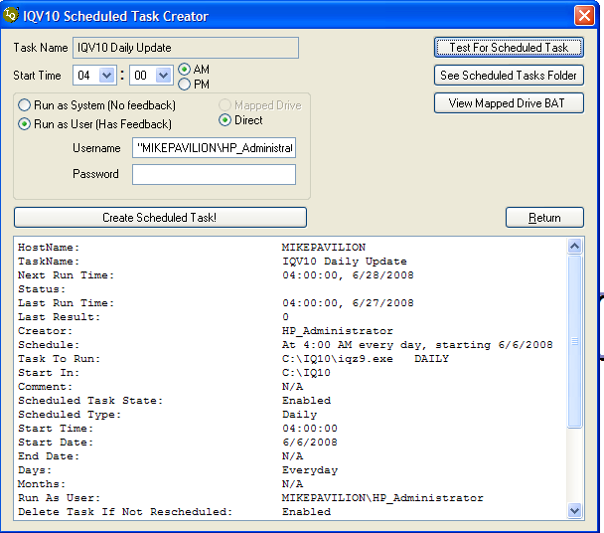

- Run local and user does not need to be logged in. If you only want the task to run when you are logged in, do not supply a password. When the system asks for a password, just hit Enter. There will be a warning dialog box then the Scheduled Task Manager will come up. Change the properties so that it says “Run only if logged on” like so:

- Run on a network but must be logged in. If you want to use a network version of IQ and you only want to run when logged in, it is the same as above.

- Run on a network but user need not be logged in. If you select this option, you will need to select the Mapped Drive option. This creates a batch file on the local hard-drive which maps the network drive long enough to create and run the task. Here is the contents of the batch file called IQV10_Daily_Update.BAT which runs IQ which is located on the Apps Share in a folder called IQ10:

NET USE V: \\Altair\Apps
V:
CD "\IQ10\"
IQZ9.EXE DAILY

Your file will be different as you will use your own drive letter, server and share name

- If you want to run as Administrator instead of a user, you can set this to run as System but the same rules apply. You will not need a password for System but you will also not get any feedback. If the System option is selected and IQ is located on a network drive, then you will have to use the Mapped Drive option as well.

Once a task is created, you can use the command button labeled Test For Scheduled Task to see the current settings. You can click on See Scheduled Tasks Folder to see all scheduled tasks including the IQV10 Daily Update task. Finally, you can click on View Mapped Drive BAT to see the contents of the drive-mapping batch file in case you need to modify it.

5: FINDING INFORMATION –
THE MUSIC CODA SCREEN
THE MUSIC CODA SCREEN

To access the advanced features of IntelliQuote Version 10 RM Edition, you must decide which user interface you want to access coins. Most people start out with the MUSIC Coda screen but other prefer the MUSIC Tree. You should try both styles and see which one works best for you. The other choice, labeled CAE Groups, is simply included for backwards compatibility but is not nearly as useful as the MUSIC Coda or MUSIC Tree. You can always switch from one to the other but to set the default (at Startup), from the Utility menu, select Preferences and you will see the Preferences screen shown below.

The preferences screen allows you to choose from three different models for accessing coin prices when the program first starts up, so you can utilize the one best suited for your individual needs. You can also customize the appearance of your quote screen by selecting to see prices in bold or normal text.

You can always choose between selection methods by utilizing the drop-down menu under “Quotes” as shown below.

The MUSIC Coda screen may appear complex at first but all of the controls have been optimized for ease of use.

Starting in the upper left-hand corner, you will see an input box labeled PCGS # with (F7) to the right of the box. This input box can be used to directly enter a PCGS number if you know it or bar scan a coin regardless of whether it is PCGS or NGC subject to the caveat presented above. No matter where the focus lies on this screen, you can always get to this box by pressing the F7 key.

Directly below the PCGS # box is an input box labeled Date with (F2) to the right of the box. If you enter a year, like 1878, all denominations of coins matching that date will appear.

Directly below the Date input box is a checkbox labeled Include: 1965-Date (indicated by *). This checkbox affects any denomination marked with an asterisk. For example, if you were to look at a list of all small cents with this check box off, you would only see small cents up to the year 1964. If you checked this box on, you would see all small cents to date. Even if you do not have this option selected, you can always see modern coins by selecting U. S. Mint Issues 1965-Date (D).

Directly below this check box is another check box labeled Present Coin Groups. Where appropriate, selecting this option will present you with an intermediate list of coins groups prior to drilling down to the Coda coin grid. An example of this will be presented below.

The green Type buttons, labeled COPPER Type (F3), NICKEL Type (F4), SILVER Type (F5) and GOLD Type (F6) only show Type coins regardless of any other options on this screen. Each of these four buttons produces a multi-denominational list of Type coins. The denominations that make up each list are shown in grey directly below the green buttons.

Back on top, to the right of the two input boxes are three vertical column sections that modify the behavior of the rest of the screen. The first section allows you see Date Only, Type Only, Date & Type Integrated and Date & Type Segregated. If you select Date Only, either by clicking on the option or typing Alt+Y, whenever you use any of the denomination buttons (grey), only Date coins will appear. If you select Type Only either by clicking on the option directly or pressing Alt+T, the grey buttons will only show Type coins. The next two options show both Date and Type coins but differ in whether Date coins are associated with their “parent” or segregated.

The next option group has an effect on both the green (Type) and grey (Denomination) buttons. If you select Mint State Only either by clicking on the option directly or by pressing Alt+S, only MS coins will be displayed. If you select proof only, only PR coins will be shown. The next two options show both MS and PR coins but differ in whether they are co-mingled or segregated.

The last set of options on the right affect both the green (Type) and grey (Denomination) buttons as well. If you select Integrate: PL & DMPL - Cameo & Deep Cameo, whenever coins come in multiple states of reflectivity, they will be co-mingled. If this checkbox is off, the various states of reflectivity will be segregated. Similarly, Integrate: Brown, Red-Brown & Red - Full Designation segregates or integrates color as well as designations like FS, FH, FB, FBL etc. We suggest you select Integrate for both of these options until you become used to the system. Later, these options can be tested when the behavior of the rest of the system becomes familiar.

The Tree button on the far right will take you to the MUSIC Tree screen, which will be reviewed below.

The lower section is self-explanatory with one bit of explanation. Each of the buttons is labeled with the single key that selects that option shown in parentheses. For example, simply pressing the “C” key will select small cents. Similarly, pressing the “I” key will take you to a listing of dimes. Whether you see through 1964 to date is determined by the Include: 1965-Date checkbox. This checkbox only affects buttons on the left-most three columns. On the right, under the heading labeled “All Other Categories” use the Alt key plus the letter shown underlined. For example, to see Coins & Tokens of Hawaii, you would press Alt+K.

To leave this screen and return to the main menu, click on the Leave button or simply press the Esc key. If you click on the Log button, you will see a listing of each input source and the time and date of last load.

When you select any green or grey button, you will be taken to the coin drill down which is shown next.

It is important to note that IntelliQuote Version 10 RM Edition “remembers” your preferences for this screen. It will always reset itself to exactly the way you left it. These preferences are stored on your disk drive so it even remembers the settings from session to session, even if you have turned the machine off and on in the mean time.
One last note. At the bottom, on the lower left-hand side, you will see a command button labeled “Quick Data Update” which operated identically to that menu option. This button kicks off the PLUS technology. Your computer checks in with the IntelliQuote RM Server and compares the version you have with the most recent version. Any source which has been updated since the last time you ran an update will automatically update that source. You should only use this when you know you have a little bit of time such as during a lunch break.

IntelliQuote will ask you one question:

If you clicked this button by accident and do not want to run the Daily Update, just click on Cancel. Otherwise, you would normally click on Yes and the downloads will proceed.

6: FINDING INFORMATION –
THE MUSIC TREE SCREEN
THE MUSIC TREE SCREEN

The MUSIC Tree is another way of finding a particular coin.

The MUSIC Tree

One of the most powerful features of IntelliQuote is the MUSIC Tree screen. You can reach this screen by selecting it from the main menu, from the MUSIC Coda screen, or making this screen your primary access screen from Preferences and starting the program.

Using this view, coin selection information is displayed using a “tree” format, similar to the way files are displayed in Windows explorer. Here is an example:

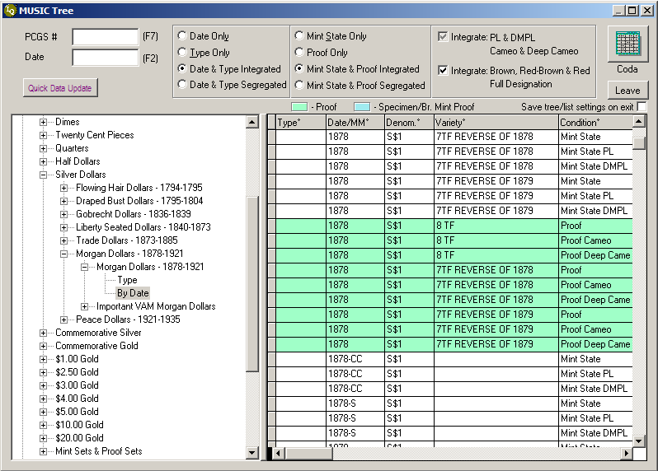

While the filter and sort options are the same as on the Coda screen, it is important to note that IntelliQuote Version 10 RM Edition remembers your selections here separate and apart from your selections in MUSIC Coda. By clicking on the plus signs to the left of the names, you dig deeper into the selections as displayed above with “Silver Dollar – Morgan Dollars”. You can then select a specific coin via the grid to the right of the directory files. You can switch back to Coda view via the icon in the upper-right hand corner. Or you can close the screen by hitting the “Leave” button.

7: FINDING INFORMATION –
NAVIGATIONAL GRID
With the exception of directly entering a PCGS number, using the bar scan or selecting the “Present Coin Groups” check box, any selection from the MUSIC Coda screen will take you to a screen which is very similar to the following grid:

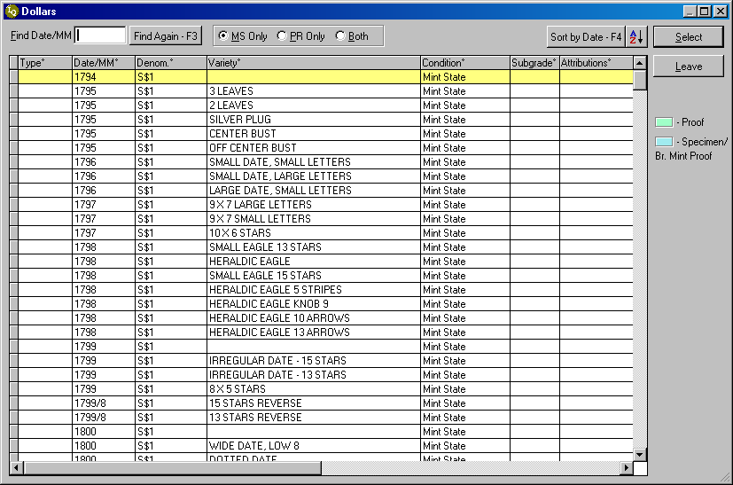

The grid in this example is typical, in this case displaying Silver Dollars. Regardless of the sort order seen initially, you can jump to the first date coin within a certain year by typing it into the Find Date/MM box and pressing Tab or Enter. If you want to jump to the next coin with the same Date/MM, click on the Find Again button or press the F3 key. This is very similar to the Find features found in Microsoft Word, Excel or other products.

You can easily switch between Mint State or Proof coins by using the option group at the top regardless of the settings on the MUSIC Coda screen. You can click on MS Only or press Alt+M to show only Mint State coins. You can click on PR Only or press Alt+P to see only Proof coins. If you click on Both or press Alt+B, you will see both MS and Proof coins integrated.

Regardless of the initial sort order, you can re-sort the grid at any time by double-clicking on any column header or moving the cursor to the column of choice and clicking on the little A-Z button at the top or pressing F5. Resorting overrides the Integrate/Segregate settings such Date/Type, Mint State/Proof, Strike or Designation. Because sorting by Date would be the most obvious, we have included a button and a special key (F4) to perform this function directly. If you elect to sort the grid via a column header, the screen will change to look like this:

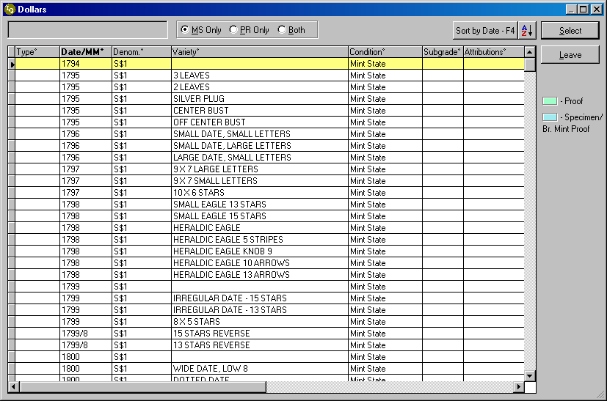

The blinking cursor at the top now utilizes a feature called the Incremental Search. This means that the highlight will always move to the first row that matches what has been typed in. For example, if you type in the number 2, the highlight row will go to the first coin in the year 2000, if there is one. If you type in 1878-C, the highlight row will go to the first coin that has the Year/MM of 1878-CC. At this point, you would use the cursor up/down arrow or PgUp/PgDn to navigate to the coin of interest.

To see information about a specific coin, double-click on that coin. The highlighted row can also be selected by pressing Enter or clicking on the Select button. You can return to the MUSIC Coda screen by clicking on the Leave button or pressing the Esc key.

If the number of coins presented in the Coda grid is overwhelming or too large to be useful, you can reduce the number of coins seen by using only a subset. The way to get a subset is to select the option labeled Present Coin Groups check box on the Coda screen. Once this option is selected, the next screen you would see would be similar to this:

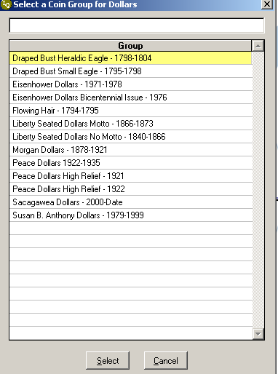

Note that this screen only appears when appropriate. For example, if you selected Trade Dollars on the Coda screen, since there is only one coin group, you would proceed directly to the grid. This group selector has an incremental search built in so using the example above, if you pressed the “F” key, the highlight bar would go to the first row beginning with an F which would be Flowing Hair, in this particular case. Press “Enter”, double-click on the item or click on Select to see the regular Coda grid, but this time, it would only be with coins that belong to this coin group.

Keyboard and Mouse Navigation Summary

Here are two examples of how to rapidly access pricing information for a particular coin. The first is for a person more comfortable with using the keyboard. The second is for a person using the mouse:

Keyboard navigation to 1878 8TF S$1 MS DMPL
Assuming that you are starting from the main menu and you have your preferences set to MUSIC Coda, you would do the following:
- Press the F8 key to access the MUSIC Coda screen.
- Press Alt+Y to force the drill down to Date Only (assuming this was not previously selected).
- Press Alt+S to force the drill down to Mint State Only (again assuming that this was not already the case) – you could always do this within the drill down.
- Typically, you will leave the two integrate options selected so we will ignore them for now.
- Press the “m” key to select Silver Dollars, which will take you to the next drill down. This presumes that Present Coin Groups is not selected.
- Type in 1878 and press the Enter key.
- The selected row is now the first entry, which is Mint State.
- Press the down arrow twice to highlight the DMPL record.
- Press Enter
- That’s it, you are now on the screen for PCGS number 097073

Mouse navigation to 1878 8TF S$1 MS DMPL
Once again, assuming that you are starting from the main menu and you have your preferences set to MUSIC Coda, you would do the following:
- Click on the Quotes menu pad
- Click on the Quotation View… bar.
- Click on Date Only (assuming this was not previously selected)
- Click on Mint State Only (again assuming that this was not previously selected)
- Click on the grey button labeled Dollars* which will take you to the drill down screen.
- Click below the thumb (the button on the scroll bar on the right) three times to perform the equivalent of three PgDns.
- Double-click on 1878 8TF Mint State DMPL
- That’s it, you are now on the screen for PCGS number 097073

8: THE MAIN QUOTATION SCREEN
The Main Quotation Screen

If you entered a PCGS number directly, used the bar scan or selected a coin from the MUSIC Coda or Tree drill down, you will be taken to the Main Quotation Screen. This screen is similar to that in previous editions with some subtle but significant differences. The Main Quotation screen looks like this:

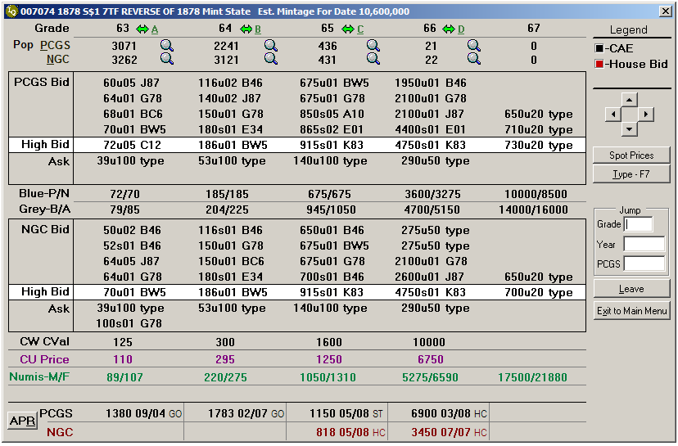

The most obvious change from previous editions is that there are five columns of data instead of four. If there is a single PCGS number for this coin, the six-digit number will be displayed in the upper left-hand corner. The grade is shown on the top row and immediately to its right is the space for the revolutionary Side-By-Side (SBS) feature. SBS is used to compare similar coins at the same grade, which differ by reflectivity, e.g. MS/PL/DMPL or color designation e.g. BN/RB/RD.

The SBS indicator is a green, double-headed arrow. In this particular example, only grade 67 does not have this indicator. If the SBS feature is available, you can access it by double-clicking on the arrow or clicking on the button directly to its right. You can also access the SBS feature by using the Alt key plus the letter shown. For example, to access SBS for grade 64, you would press Alt+B. The SBS screen looks like this:

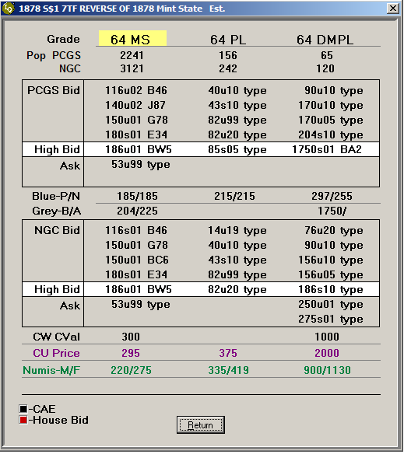

Returning to the Main Quotation Screen, directly below the grade are two lines dedicated to PCGS and NGC population by grade. If you click on any of the population figures, you will see the time and date stamp of when that population data was loaded.

In many cases, there may be more than one NGC number that corresponds to that particular PCGS number. NGC assigns different numbers to coins based upon its pedigree, among other things, so it is very difficult to determine the actual NGC population for a given grade. IntelliQuote Version 10 RM Edition solves this problem neatly by summing together the populations and showing the totalized figure. If you want to see the actual varieties and pedigrees that make up that number, simply double-click on the magnifying glass or press the Alt+N key. You will get a screen that looks like this:
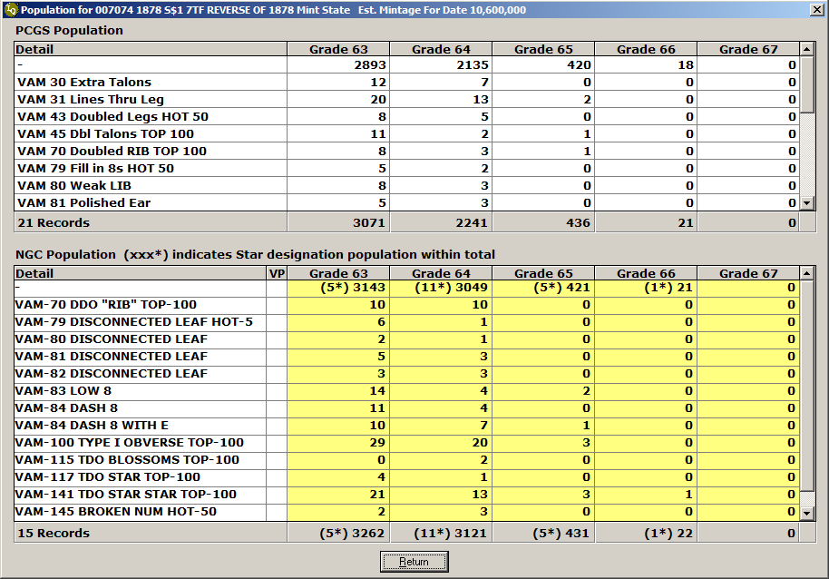

This screen was produced by double-clicking on the magnifying glass next to the 1438 figure under grade 63. The highlighted column reflects this. If you drill down to this screen by pressing Alt+N, the entire lower grid would be highlighted. You will note that not every coin has a population at every grade. If you simply wanted to know how many records were used to build the population figure, simply hold the mouse over the magnifying glass in the Main Quotation Screen to see the count of non-zero population records.

You can expand one grade by clicking on the plus sign:
Continuing on the Main Quotation Screen, the next seven rows show the ATC PCGS Bids and Asks for that coin at each grade. You can click on each bid or ask and you will see the log screen with that data source highlighted. This screen looks like this:

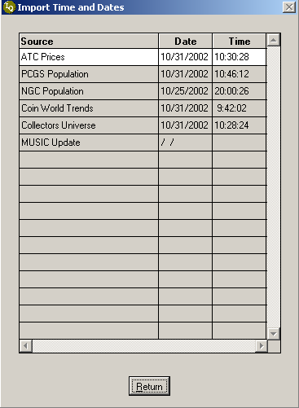

If you see a Trader ID to the right of each bid, you can click on their ATC code to see more details about that trader. The Trader Detail screen looks like this:

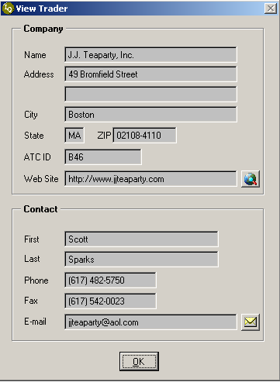

If there is a web site listed for this trader, and you are online, you can click the little button with a globe and your web browser will go directly to their web site. If there is an email address listed and you use Microsoft Outlook as your email client, clicking on the little button with an envelope will start an email to that person.

Other data sources behave similarly as the ATC PCGS Bids and Asks. Clicking on each price will show the time and date of when that data was loaded. Clicking on a Trader ID will bring up the Trader Detail screen.

You can navigate to other grades by clicking on the left or right arrows or using the left and right cursor keys. You can change to another coin by clicking on the up or down arrow or using the cursor up/down keys.

If you want to jump to another grade directly, simply type it in the Grade Jump input box. If you want to go to another year within that denomination, simply type the year in the Jump box. If you want to go to another coin and know the PCGS number, simply type it into the PGGS Jump box. You can also bar scan in a PCGS or NGC bar code in this box. If you want to see the Type coin for a given date coin, simply click on the Type button or press the F7 key. If you do that, the screen will change to the following:

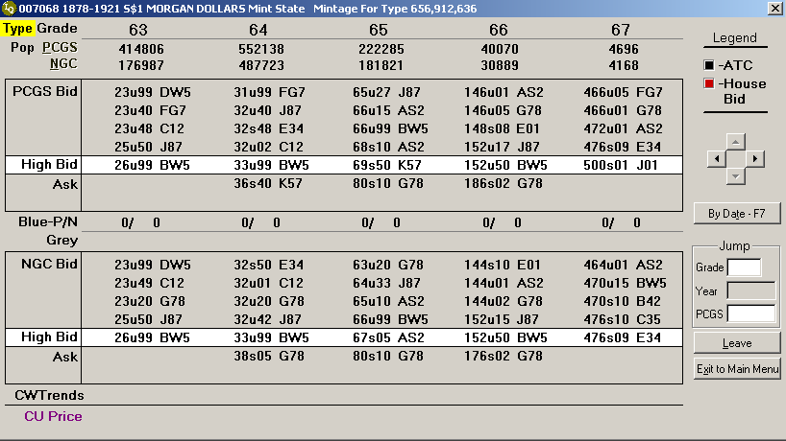

You return to the original screen by pressing the F7 key again or clicking on the button whose caption has changed to reflect that this will be the case.

You can return to the prior grid by clicking on Leave or pressing the Esc key. You can return to the main menu by clicking on the button labeled Exit to Main Menu or pressing the Alt+X key.
Variety Plus

9: THE UTILITY MENU
Backing Up Your Data

You should backup your data once in a while. The program will automatically backup on Sunday nights but if you are in the middle of a show and cannot afford the downtime, you might want to manually backup more often. Simple click on Utility/Backup Data… and the program will show the following screen:

There is a timer involved. If you do not answer within 10 seconds, the program will backup anyway. The purpose of this screen is to give you a chance to abort the operation if it was selected in error. You may also use this to abort the operation if it is launched automatically on Sundays and you don’t want to continue.

Restoring Data

If you ever get an error message that indicates that your data or indices have become corrupted, you can use the Utility/Restore Data… option to recover the last set of data you backed up. The dialog box is very simple:

Just click on Yes or wait 10 seconds and the restore operation will begin. Please note that the data is only as current as the last time you backed it up. If you only backup on Sunday nights, once the data is recovered, you may wish to manually update all sources. Otherwise, you can wait for the nightly update operation to bring your data up to date.

Spot Prices

Traders
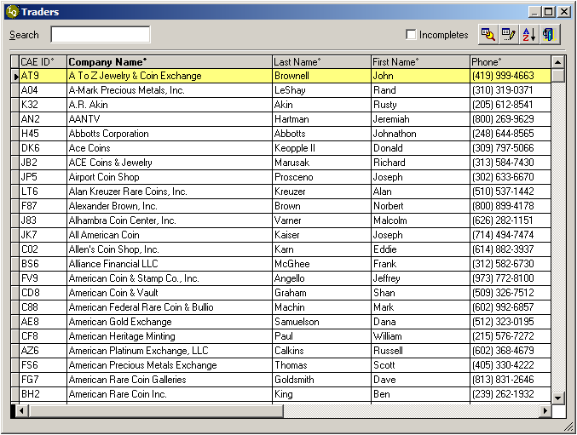
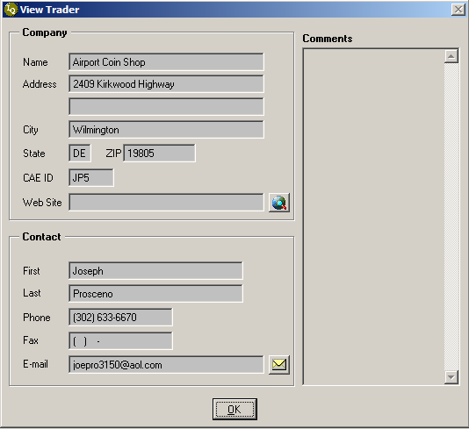

10: THE HELP MENU

Getting Help
Live Remote Assistance
ABOUT INTELLIQUOTE

APPENDIX

1: TROUBLESHOOTING

DURING INSTALLATION
- If you have a content filtering firewall, you must place www.iqcoin.com and www.coinlists.com in the exception list
- If you are running Windows Vista or Windows 7 or Windows 8, you need to Run as Administrator during setup, the first time the application is run and when you want to set up a scheduled task (which can be during the first time)

DOWNLOAD PROBLEMS
- You must download all sources manually one time to create the necessary conditions for them to auto-download using the scheduled task
- If you decide you no longer want to have a source auto-download, you will need to disable this source.
  - Select Data Import from the menu then click on the More… label (in green) in the lower left hand corner of the Data Import form. This will open up a small panel with two command buttons prefaced by the words “Editing Functions.”
  - Click on the Edit Sources button to get to the Import Sources grid.
  - Click once on the row corresponding to the source you want to disable and then click on the edit toolbar button.
  - Click on the Disable Daily Update button
  - Answer Yes
  - Click on Save and then return
- If you have ANY firewall set up, make sure you ALWAYS allow IQZ9.EXE and VEGENHTTP.EXE to download files.

DATA CORRUPTION
- If you get any error messages regarding table corruption or index problems, just ignore every error message until you get to the main menu. Select Utilities/Restore Data and all of your data tables will be restored to the previous backup.
- At this point, just select Quotes/Quick Data Update and within minutes, all of your data will be updated since the last backup.

2: How to Disable a Daily Download in IntelliQuote Version 10

- Within IQV10, select Data Import… from the Quotes menu:

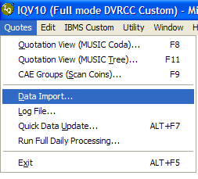

- This will bring up the normal import screen. Click on the caption “More” in the lower right hand corner:

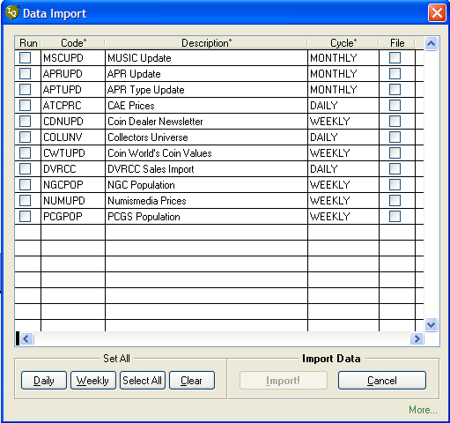

- This will show a few new options. Click on the icon for editing sources. The tooltip will say “Edit Sources (Caution!)”:

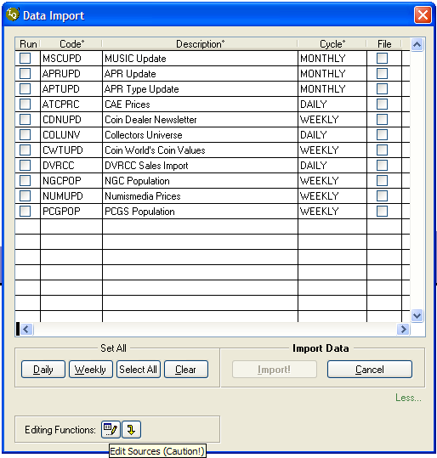

- This will bring up a grid with the current import sources. Select the one you want to disable. In this example, we will use Coin World to illustrate the process:

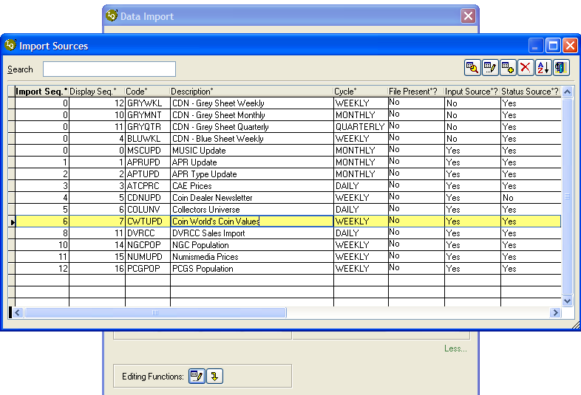

- Click once on the source and then click on the Edit toolbar button. This will bring up the edit screen for that source entitled “View Import Type” :

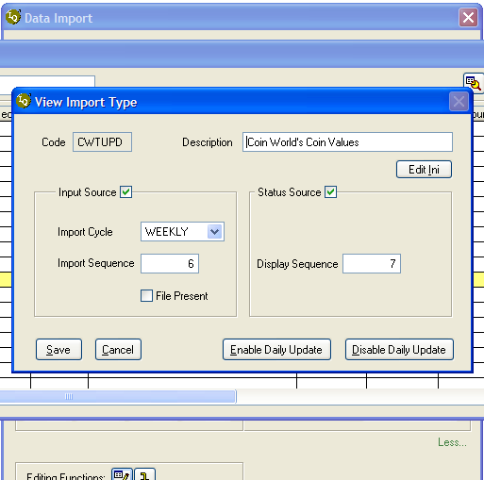

- Next, click on the button in the lower right hand corner entitled “Disable Daily Update”:

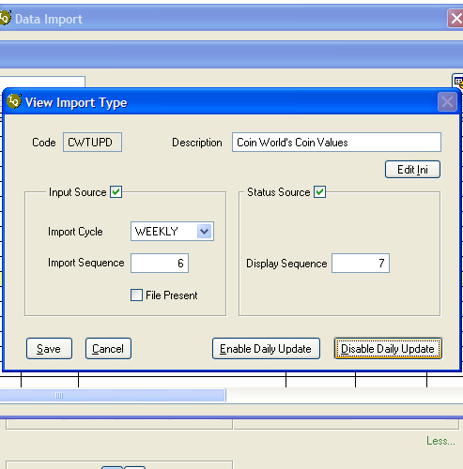

- Then click on the Save button in the lower left hand corner. This will stop IQV10 from automatically trying to download that source during Quick Updates or the scheduled task for Daily Updates:

